DOKUZ EYLUL UNIVERSITY
ENGINEERING FACULTY
DEPARTMENT OF COMPUTER ENGINEERING

CME1251 PROJECT BASED LEARNING – I
FINAL REPORT
PROJECT – II

11 22 33

by
Gürkan Bıyık
Ahmet Kağan Kervan
Eralp Çolak

Lecturers
Assoc.Prof.Doc. Derya Birant
Res.Asst. Meltem Yıldırım

01.12.2021

CHAPTER ONE
PROGRESS DESCRIPTION
First week, we talked each other. We made a plan and task-share. Then, we start coding the project. We created neccessary variables, print the game-board, coded cursor movement with using arrow keys. Second week, we created a function that generates random digits and place them randomly into the game-board. We coded function of w and s key that just move the single numbers. Third week, we coded function of a and d key that just move the single numbers. Then, we worked hard on macthing system. Eventually, we made it. Fourth week, we add a fucntion to the code which checks if the game is over. With this function, if there is no single number in the game, game over.

CHAPTER TWO
TASK SUMMARY

Completed Tasks
Gürkan Bıyık; I used random function as random variable for the generating numbers for rows, column and choosing 1 or 2 or 3. Then i used this values in the setcursorposition with console.writeline. With all thoose, i printed numbers which is 1 or 2 or 3 on the game board. With using for loop to repeat that process 30 times. I made matching numbers and deleting them after matches

Ahmet Kağan Kervan; I adjusted the variables, drew the game board and made cursor movement. I made calculating the score and printing them.
Eralp Çolak; I made the selected number move up and down with W and S keys.
I made the selecting number move with A and D keys as far as it can go.

Incomplete Tasks: Reasons and Explanations
Gürkan Bıyık -

Ahmet Kağan Kervan -

Eralp Çolak -

Additional Improvements to the Project
When the digits matches, they are highlighted.

CHAPTER THREE
EXPLANATION of algorıthms

Screenshots
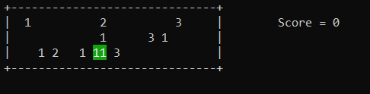
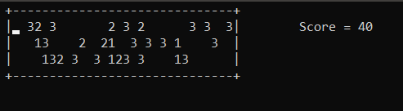
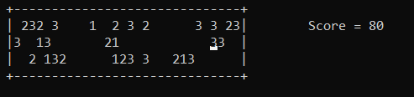
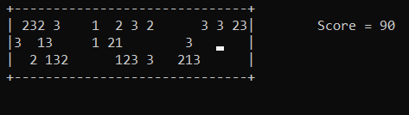
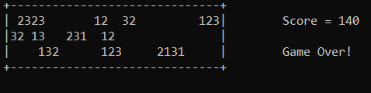

Functions
Thread.Sleep, random.Next, (Functions we made) create_number(), game_over()

Algorithms and Solution Strategies
Gürkan Bıyık; I solved printing random numbers between random point on the game board with using random function.

Ahmet Kağan Kervan; I use ‘SetCursorPosition’ command to writing ramdom generated numbers to game board and move the cursor . I use ConsoleKeyInfo variable , ‘Console.ReadKey’ command and KeyAvilable bool to move cursor.

Eralp Çolak; I created array variable to recall numbers and assigned values ​​there. I used these arrays to recall numbers.

CHAPTER FOUR
PROBLEMS ENCOUNTERED
Gürkan Bıyık; It came to me hard to figure out what write function to use after using setcursorposition.

Ahmet Kağan Kervan; It came to me hard to figure out what write function to use after using setcursorposition.

Eralp Çolak; ; At first, I created a while loop to generate another random number if the generator generates a number on a full index. But for some reason it was sometimes working, sometimes generating random numbers non-stop on that line. Then we fixed it with for loop.

CHAPTER FIVE
conclusıon
In this project, we learned arrays and console.key function.

REFERENCES
https://stackoverflow.com/questions/2743260/is-it-possible-to-write-to-the-console-in-colour-in-net

AppendIx A
Poster/Web page of the Project
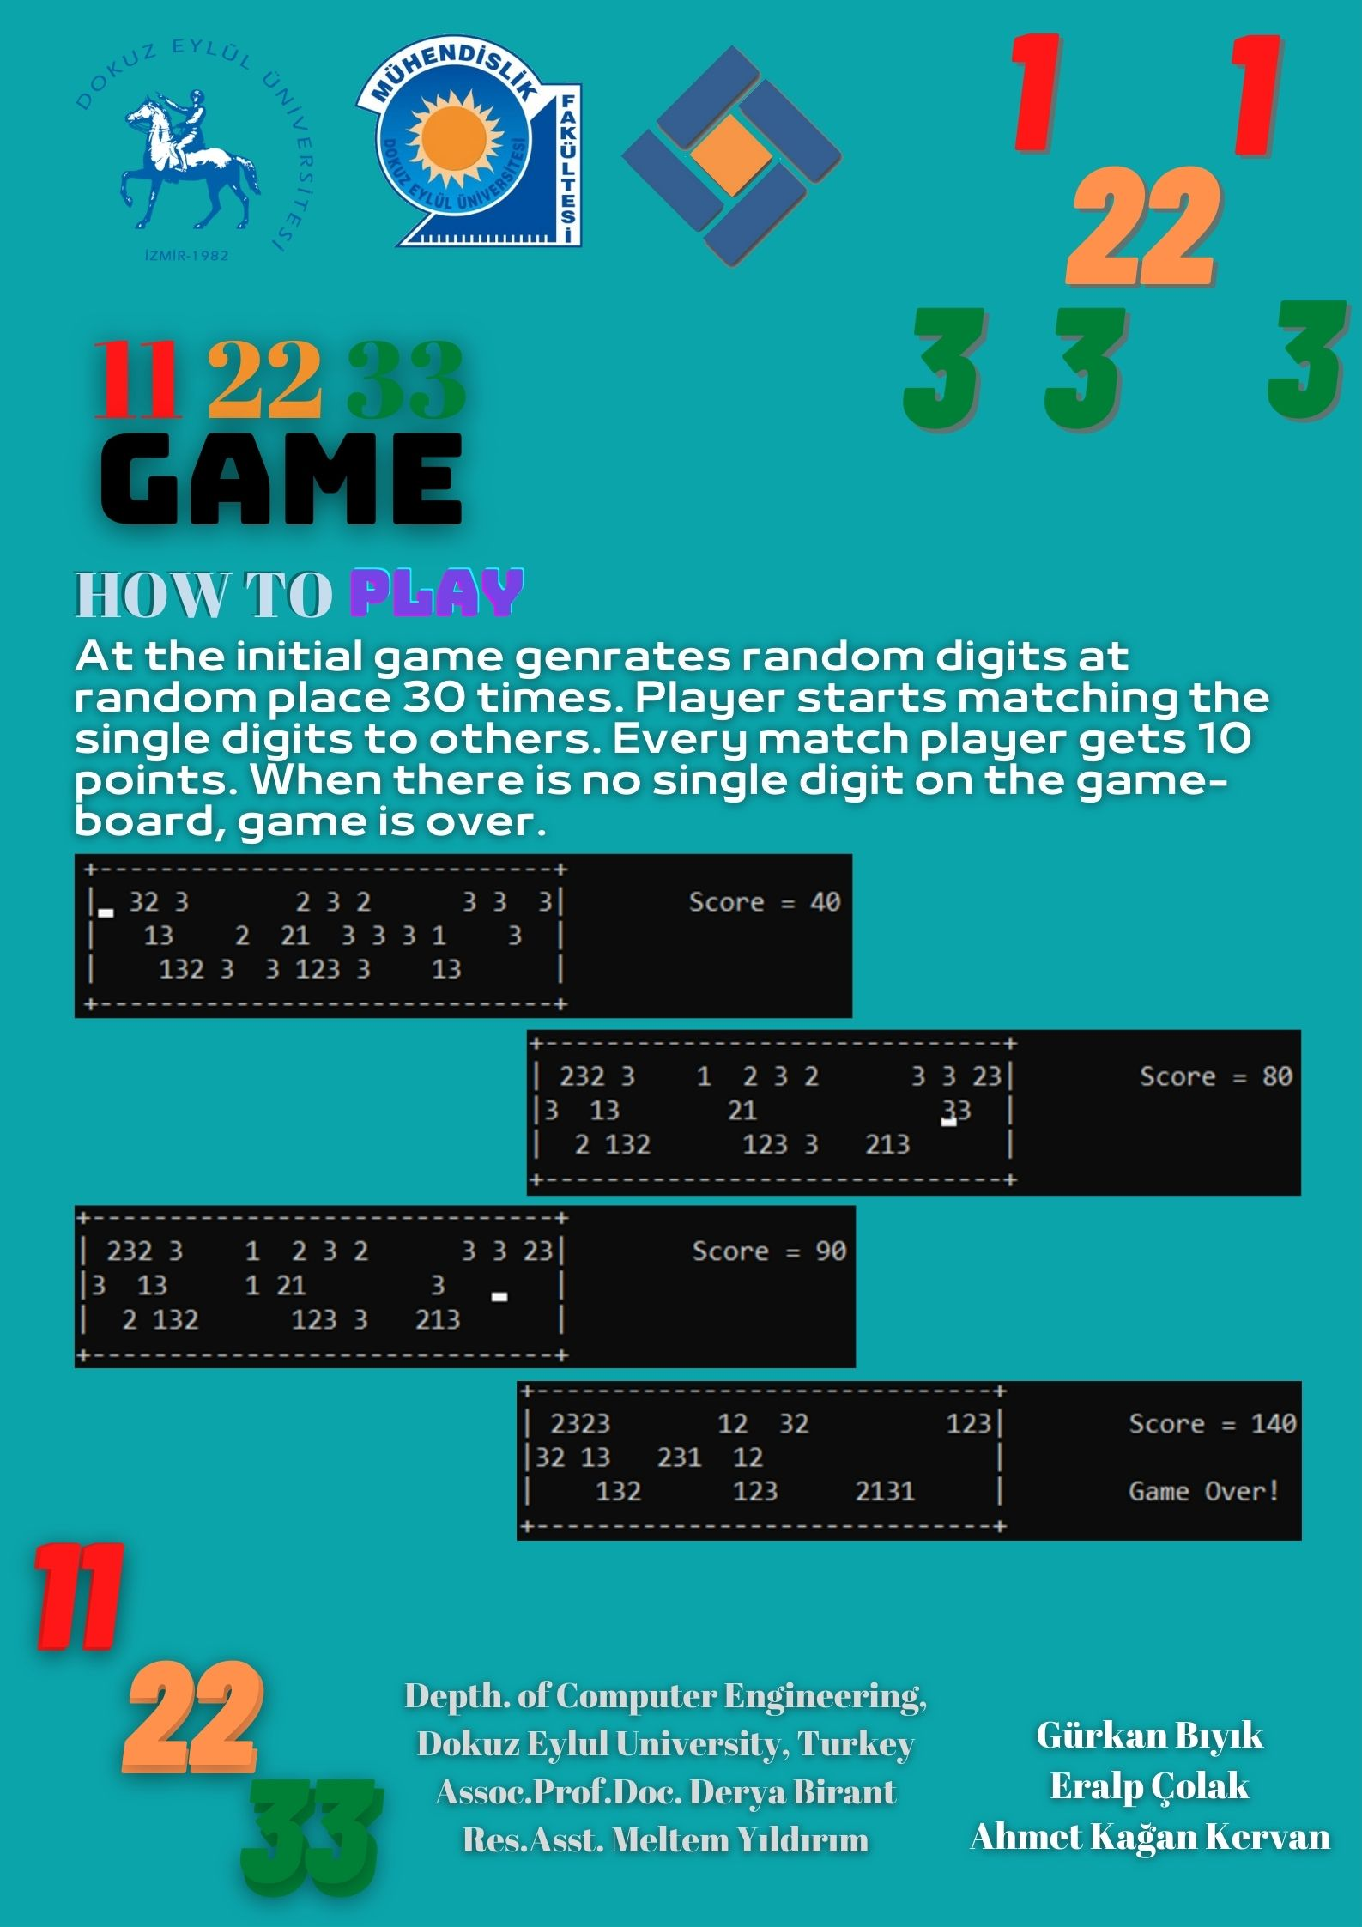
AppendIx B
Code of the Project
// checks wheter game over
bool game_over()
{
bool check = true;
for (int a = 1; a <= 30; a++)
{
if ( // if
(row1[a] != 0 && row1[a - 1] == 0 && row1[a + 1] == 0) // this condition
|| // or
(row2[a] != 0 && row2[a - 1] == 0 && row2[a + 1] == 0) // this condition
|| // or
(row3[a] != 0 && row3[a - 1] == 0 && row3[a + 1] == 0) // this condition
) // become true
{
check = false; // game is not over (return false)
}
}
return check; // if check do not become false returns true and game is over!
}
//the game
while (true)
{
if (Console.KeyAvailable)
{
cki = Console.ReadKey(true);
.
.
.
.
.
.
.
.
.

